UNITED  NATIONS | 

UNEP/MC/COP.6/Dec.9

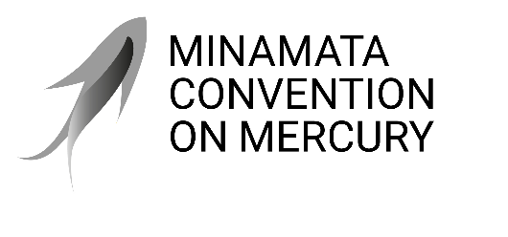 |  | Distr.: General  24 November 2025  Original: English

Conference of the Parties to the
Minamata Convention on Mercury
Sixth meeting
Geneva, 3–7 November 2025
Decisions adopted by the Conference of the Parties to the Minamata Convention on Mercury at its sixth meeting
Decision MC-6/9: Advancing work related to mercury waste
The Conference of the Parties,
Recalling that, in decisions MC-3/5, MC-4/6 and MC-5/10, the Conference of the Parties to the Minamata Convention on Mercury decided on thresholds for different categories of mercury wastes under article 11 of the Convention,
Welcoming with appreciation decision BC-17/14 of the Conference of the Parties to the Basel Convention on the Control of Transboundary Movements of Hazardous Wastes and Their Disposal, according to which the work programme of the Committee Administering the Mechanism for Promoting Implementation and Compliance for the biennium 2026–2027 includes a review of information provided in national reports on illegal traffic of mercury wastes, in response to the invitation in paragraph 12 of decision MC-5/10 of the Conference of Parties to the Minamata Convention on Mercury,
Welcoming decision BC-17/7 of the Conference of the Parties to the Basel Convention, in which the Conference decided to update the technical guidelines on the environmentally sound management of wastes consisting of, containing or contaminated with mercury or mercury compounds in order to reflect adjustments consequential to the establishment of the threshold for mercury wastes falling under paragraph 2 (c) of article 11 of the Minamata Convention on Mercury, in accordance with decision MC-5/10,
Recognizing that the environmentally sound management of mercury waste remains particularly challenging for developing countries, and taking into account article 14,
- Invites parties and relevant stakeholders to submit, as appropriate, any proposed updates to the lists in tables 1, 2 and 3 of the annex to decision MC-3/5 to the secretariat no later than six months before the seventh meeting of the Conference of the Parties for the secretariat to compile, subject to the availability of resources, for consideration by the Conference of the Parties at its seventh meeting;
- Requests the parties and the secretariat to take the actions agreed on in decision MC-5/10 as soon as practicable or as required to facilitate the implementation of article 11;
- Requests the secretariat to compile and summarize submissions from parties and relevant stakeholders of any scientific and regulatory data on the effectiveness of the threshold for waste falling under paragraph 2 (c) of article 11, as well as on challenges and experiences related to its use, for consideration by the Conference of the Parties at its seventh meeting;
- Also requests the secretariat to compile and summarize submissions from parties of any information on the implementation of the different approach referred to in paragraph 2 of decision MC-5/10, for consideration by the Conference of the Parties at its seventh meeting.

