36th Working Group Meeting of the MEA IKM Initiative
14th March 2016 - Bonn, Geneva, Montreal, Nairobi

Report

Meeting Participants

BRS – Osmany PEREIRA
CBD – Kata KOPPEL
Minamata – Stephanie LARUELLE
SAICM – Muhammed OMOTOLA
UNFCCC – Rita BENITEZ
UNEP/DEPI – Kanako HASEGAWA
DEWA – Ludgarde Coppens, Priyanka DeSouza,
UNEP/DELC – Eva DUER, Kelly KABIRU, Iddah KAMAU (IKM Team), Maria Elissavet STAVRAKA
Consultants: Cristian ROMANESCU (Eau de Web)

Meeting Summary

After welcoming the participants, the IKM team thanked the UNFCCC for representing UNEP at the VOCBench stakeholder meeting held in February 2016 which could not be covered by the IKM team due to conflicting missions.

VOCBench Stakeholders’ Meeting (Luxemburg 23-24 Feb 2016)

Ms. Benitez (UNFCCC) briefed the group on the VOCbench meeting held on the 23rd and 24th of February 2016, in Luxembourg, and in a few words described the VOCBench tool which was chosen to support the LEO development due to its ability to host and cross-link LEO with individual vocabularies of MEAs. At the meeting, more than 80 requirements were submitted by the group of stakeholders of the tool which include FAO and the EU. Ms. Benitez conveyed the IKM requirements to the VOCBENCH 3.0 project, and noted the invitation to map the LEO and MEA vocabularies to FAO’s Agrovoc ((the ontology created and used by the FAO to support global indexing of agricultural content) by FAO. Ms. Benitez further referred to the discussions on integrating vocbench with content management systems.

Integration of LEO with content management systems (drupal, sharepoint)

In this regard, Mr. Romanescu (Eau de Web) briefly explained that VOCbench had been integrated with drupal in the context of InforMEA, by exporting the ontology as RDF file which is regularly providing updates through a 15 minute interval. Currently issues with regard to the use of VOCbench can be relayed to a google group which gets back with solutions to issues reported by users.

Ongoing validation effort

The IKM team thanked MEAs for their review of LEO and invited those who had not yet done so to proceed swiftly so that translation could proceed before the approaching end of the project period.

Mr. Pereira (BRS) confirmed that the BRS Secretariat in the coming weeks would validate the LEO and that this process will be finalized by May.

Reference to LEO in the context of SDG ontologies/ DEWA tools:

The IKM then welcomed UNEP DEWA colleagues, who briefed the group of the interest of UNEP live and DEWA to refer to LEO in the context of the SDG Ontologies. Ms. DeSouza briefly described to the difference between “taxonomy” and an “ontology”, and further referred to the efforts to directly relate SDG goals, targets and indicators to MEAs (see example below). DEWA further confirmed that they would display LEO in a way that would and the general interest in referring to LEO, thereby providing traffic back to the InforMEA tool.

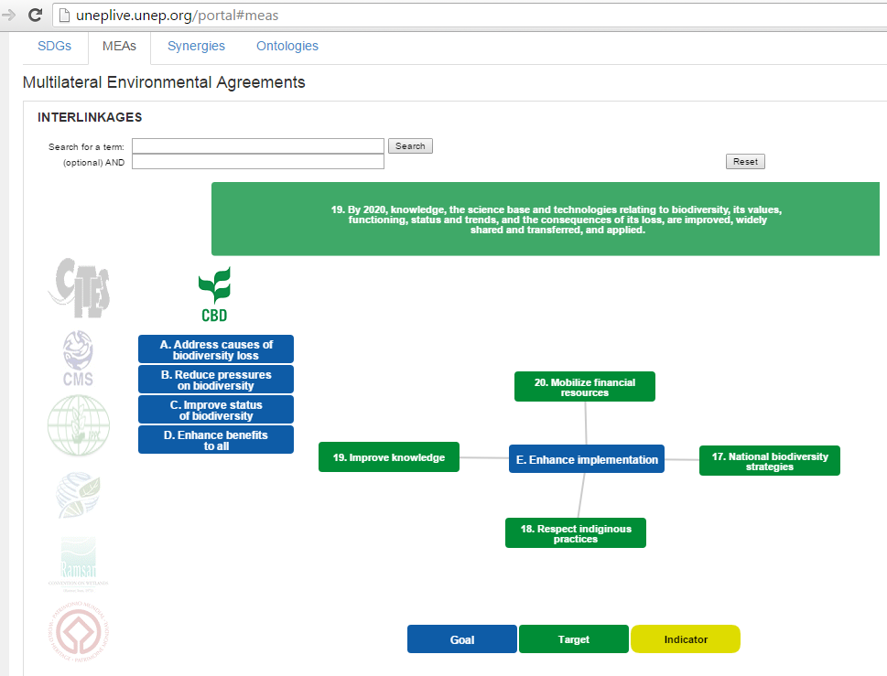
.

Putting Leo to Use

The need to put the LEO to use during the InforMEA Phase II was discussed and the best possible use of the shared resource for the MEAs in the context of this project component.

Approach to tagging

Mr. Pereira also confirmed that BRS has tagged as part of its document management system in the past and will provide a mapping to LEO – so that the appropriate tags will be exposed to InforMEA through the API.

Ms. Kanako (Regional Seas Programme) confirmed that there was no tagging system currently in their system, but would be interested in automated tagging method. Ms. Duer considered the current data inputting process in the context of the development of a shared database infrastructure for initially three regional seas conventions an excellent opportunity to consider the semantic tagging of COP-Decisions.

Role of LEO, taxonomies and other ontologies

Mr. Pereira further clarified that during the meeting in Bonn on designing LEO principles, it was decided chemical and species lists not to be included in the ontology, but be separated, for ease of using and size considerations. He asserted that the BRS has tagged internally these lists separately. He also stated he will check if the API allows such inclusion, and if not , he emphasized the need to amend the API (see Addendum below). Mr. Romanescu confirmed the benefits in separating these lists.

Ms. Desouza confirmed that UNEP/Life will circulate a document with guidelines on tagging, whereas Ms. Duer recognized the benefits of getting the know-how on STG ontology.

Automated Tagging

Mr. Romanescu reported on the analysis of two types of solutions – web-services or standalone applications (for content tagging locally): Of different tools available Eau de Web considered MAWI a free application from New Zealand a possible option to be validated through upcoming tests on sample documents outcomes of which will be shared with the group.

Ms. Benitez agreed with the benefits of machine learning and rules building software. She also highlighted the importance of content construction and predefined taxonomy to achieve the ability of assigning tags automatically, based on predefined ontology.

Ms. Koppel (CBD) stressed the importance of human intervention needed for the automated tagging to operate. She also confirmed that a software whose license is for a lifetime (not renewed) would be the financially most sustainable.

How best to use the resources associated to the project component

Reference was made by UNFCCC and CBD to the different stages of different MEAs in the context of taxonomies and ontologies, systems supporting their application and tagging mechanisms and the need for a shared resource and proposed outcomes to take full account of these differences.

It was subsequently agreed that the current status quo in participating MEA Secretariats should be fully established to better assess the best and most appropriate use of the shared resource. The below tables are suggested to be shared for completion (via google doc) for this purpose.

Scenario at MEA level
I | The MEA has an ontology in place in its own document or content management system and documents have been tagged in the past
II | The MEA has an ontology but not yet comprehensively tagged its documents and no supporting content management structure/document management structure
III | The MEA has no own ontology but would be interested in tagging its past and future key documents
IV | The MEA has no own ontology but would be interested in tagging to its very own ontology in the future
V | The MEA has not ontology and no plans to tag documents in the medium term future
Possible Resource Requirements to be considered under Phase II
- Autotagging software
- “Teaching” of automated software
- Manual tagging
- Review and recommendation on tagging approach for MEA
- Mapping of MEA ontology to LEO
- Any other (please describe)

Convention Secretariat | Applicable Scenario |  | Resource Requirements
Basel
Rotterdam
Stockholm
CBD
Cartagena P.
Nagoya
CITES
CMS / AEWA
ITPGR-FA
Minamata Convention
Ozone Secretariat
SAICM
UNCCD
UNECE
UNFCCC
World Heritage Centre
Barcelona
Abidjan
Cartagena
Teheran C
Carpathian C

