44th Working Group Meeting of the MEA IKM Initiative
Tuesday, September 5, 2017 3:00 PM - 4:30 PM CET
Bonn, Bucharest, Gland, Geneva, Montreal, Nairobi, Washington

Report

Meeting Participants

Moderator - Eva Duer
BRS – Julien HORTONEDA
CBD – Olivier DEMUNCK, Kata KOPPEL, Alexandre RAFALOVITCH
CMS - Aydin BAHRAMLOUIAN
CITES – Haruko OKUSU, Shasika SEDARA-HETTIGE
IUCN –Alexandra FANTE
Ramsar – Ed JENNINGS, Manuel KERN
SAICM - Jose DEMESA
UNFCCC – Rita BENITEZ

KM Team
UNEP – Eva DUER, Kelly KABIRU, Iddah KAMAU, David OCHOLLA,
EDW –Andrei MELIS, Cristian ROMANESCU, Lulian STAVERESCU
Consultant – Jim MANGIAFICO (Akoma Ntoso)

Meeting Summary

Ms. Duer welcomed participants and gave an overview of the agenda.

I. Technical Issues

- Server and Hosting:

EDW presented their report on the status of the InforMEA server and concluded that while further consultations with BRS would provide a more conclusive picture, it was evident that the server was in need of higher capacity, better performing hard disks, and more memory. This is especially important if the hosting of other applications such as the DART project is to be considered.

- Alternatives to OData:

An assessment of GraphQL was presented through Mr. Romanescu (EdW) which concluded that the cost of building and maintaining a GraphQL solution as an alternative to OData outweighed the benefits identified in the assessment. The analysis suggested that it would take considerable effort for an MEA to implement a GraphQL endpoint taking into account that both solutions would have to be kept maintained in parallel.

Mr. De Munck added that CBD was testing GraphQL and had noted that the solution did not provide ‘URL querying’ as currently supported by OData. Mr. Hortineda (BRS) noted that while it was important to monitor new technical developments and potential alternatives to OData, it was likely to be an expensive undertaking. Mr. Kern (Ramsar) added that, maintaining several solutions would be a resource intensive commitment also from the InforMEA point of view.

- Options for tracking InforMEA SC Recommendations:

EDW also presented their report on the use of JiRA for tracking SCM recommendations. it was noted that the JiRA application may be too complex for the task required and the continuation of using ‘Redmine’, an issue management tool, was recommended instead for the tracking of SC recommendations. Mr. Rafalovitch (CBD) clarified that there is a ‘free’ version for non-profit organizations and this would be reflected in the final report.

Mr. Rafalovitch indicated he had been unaware of an already existing solution which would be equally welcome. Mr. Kern as a long time JiRA practitioner confirmed that, it was a great tool that was simple to use but could get complex depending on its configuration.

It was agreed that unless, upon further consideration by the attachment, a participant had continued concerns, for the time being there was no compelling need to switch, at this point in time , to a different API technology or progress monitoring software for SC decisions. It was agreed that the issues will be re-considered ahead of the next SC Meeting.

- Akoma Ntoso:

Mr. Rafalovitch and Mr. Mangiafico informed the meeting on the progress made on the Akoma Ntoso exercise. Mr. Rafalovitch referred to demo links previously shared by Ms. Duer where a re-creation of a treaty search tool through the application of Akoma Ntoso could be demonstrated based on a partial mark up of CBD decisions. Mr. Mangiafico had used documents from CBD of a considerable degree of complexity, and as requested by CBD would still add annotations to provide indication of the work load associated with a more comprehensive mark up.

Mr. Rafalovitch referred to the shared google doc and reiterated the invitation to MEAs to provide their documents, for testing. With regard to the option of requesting funds from UN HLMC for the implementation of Akoma Ntoso for InforMEA, it was agreed that the outcome of the initial consultancy will help lay out the best possible solution to be envisaged by InforMEA and guide the request in terms of scope and ambition.

The handling of ‘annexes’ to Decisions across all MEAs, considering that these are not structured uniformly, was an issue worth further exploring in this regard. Mr. Mangiafico reiterated that Akoma Ntoso was best suited for legal documents as they follow a well-defined structure but annexes had varying formats that had no native vocabulary in Akoma Ntoso.

Mr. Rafalovitch reiterated that the original intent for seeking an audience with UN HQ on Akoma Ntoso was to inform them that the IKM Initiative was evaluating Akoma Ntoso for its own requirements. Any requests for support would be made based on the results of the said evaluation and the determination of the next steps. He commended the steps taken to engage the consultancy that would facilitate the assessment and he proposed that the Initiative continues in this direction. The InforMEA team will therefore prepare a communication in this regard.

Action Points:
- Finalize testing the server and evaluating the needs to advise on the actual requirements for upgrading the server.
- Proceed with setting up “Redmine” as the progress monitoring system against Steering Committee Recommendations of the InforMEA Initiative, as well as against project outcomes and the IT contract deliveries
- Monitoring technical developments about future alternatives to OData, which remains the standard for API implementation for the near future
- Preparing communication to UN HLCM informing of the ongoing investigation into the option of piloting the document standard Akoma Ntoso by INformEA Initiative

II. LEO Thesaurus and Semantic Indexing

It was noted that pursuant to recommendations of the Steering Committee meeting earlier in June, UNFCCC and CITES had expressed interest investing in auto-tagging solutions, and were willing to be part of a pilot exercise on the same, while other MEAs had also expressed their interest in following this process, such as Ramsar. MEAs who had not already done so were invited to notify the KM team of their interest in attending the meeting with REEEP, Semantic Web Company, IUCN Environmental Law Centre and Eau de Web in Vienna, especially those that have semantic indexing as a priority in the own agenda and those that would like to consider pooling resources for Secretariat-level solution.

Action Points:
- Confirm participation of interested MEAs to the Vienna meeting
- Proceed with conclusion of SSFA with circulated TORs/Implementation plan

III. E-learning, Outreach and Usability

Ms. Duer informed the participants that a Course on Human Rights and the Environment has been launched and there was an opportunity to promote this course at the third session of the Meeting of the Parties to the Protocol on Pollutant Release and Transfer Registers (Protocol on PRTRs) to the Convention on Access to Information, Public Participation in Decision-making and Access to Justice in Environmental Matters will take place in Budva (Becici), Montenegro, on 15 September 2017, which she is to attend.

She also informed the meeting that the interface of the InforMEA E-learning Portal had been upgraded and that the Portal now had 5,600 registered users from all around the world. Further, the KM team had initiated an outreach activity of engaging academia, both for visibility and to pursue any mainstreaming opportunities. So far, three universities in Kenya had been approached, who were interested in mainstreaming the InforMEA courses into their curricula.

Ms. Duer added that in line with the SC recommendation a course on Pollution and Health was under preparation and due to be launched ahead of the United Nations Environment Assembly (UNEA) that would be held from 4-6 December 2017 in Nairobi, Kenya among other things to provide more visibility to the initiative.

A course on Farmer’s Rights, that is being developed in collaboration with the International Treaty on Plant Genetic Resources for Food and Agriculture (Plant Treaty), is also due for release, and a course on the International Plant Protection Convention is under preparation. Ms. Duer invited any other suggestions for courses for consideration.

the team also informed of the meeting on Outreach with Communication Officers from the Biodiversity Cluster, later that week on 7 September in the CITES Meeting room, and added that the meeting was open to the Information/Communication Officers from other MEAs as well. The purpose of this meeting was to enhance buy in from public information officers from MEAS and to jointly identify outreach opportunities as recommended at the Steering Committee meeting in June.

Participants were invited to visit twitter and Facebook of InforMEA and to like the initiatives social media pages and share content.

Action Points:

IV. Sustainable Development Goals and MEAs

those MEA representatives who had not yet done so were invited to provide their review on the draft mapping of MEA texts and strategic plans to SDGs. Ms. Fante noted that it would be worthwhile analyzing the content already received in the context of the requisite National reports submitted as a reference source of information when validating the mapping.

Ms. Duer then informed the participants about the ongoing discussion on the Data Reporting Tool (DaRT) project that is building on the Target Cross-linking Tool (TCT), and has a link to the CBD Online Reporting System. The idea behind the tool is to identify how MEA implementation is linked to SDGs, and in the case of the biodiversity cluster, the link between SGDs and the Aichi Targets.

Action Points:
- Obtain clarity on way forward on DART and adjust project documentation accordingly
- Last round of follow up on SDG mapping ahead of next WG Meeting

V. AOB

A) Request for Observer Status for the Inter-American Institute for Global Change Research: There was no objection to the request and thus the KM team would communicate the approval of the said request to the requesting organization.

B) Introductions: Mr. Demesa introduced himself to the group saying that he had taken up the role of Mr. Muhammed Omotola as the InforMEA Focal point for SAICM.

C) Updates by MEAs:
CMS – Mr. Keil is currently attending the meeting for Information Officers in the Biodiversity Cluster in Geneva. The tagging project is ongoing and while the meeting in Vienna would be welcome, it comes at the end of the CMS COP and would be difficult for CMS to attend. The development of TORs that would benefit from the new Systems Contract is ongoing.

UNFCCC – COP 23 is in Bonn in November. The new UNFCCC Drupal-based website will be launched at that occasion but the change of platforms has implications on the InforMEA API, a situation that is currently being looked into. The work on the UNFCCC taxonomy is ongoing.

D) Next meeting: November. Date to be proposed.

Action Points:
- Welcome the Inter-American Institute for Global Change Research as an observer to the InforMEA Initiative
- Explore the best way forward to re-establish the API with UNFCCC
- Set up individual meeting with new SAICM representative and InforMEA team
- Confirm proposed dates for next Working Group Meeting

Annex 1 - EDW report on InforMEA Sever health status

1. We have identified a few places in the portal causing high load on the CPU and I/O. We will address them by tuning the cache and rewriting some parts of the code (not done yet)
2. Confirmed that the PHP, MySQL and Drupal settings are similar on test vs prod (we are using the same recipe for deployment). The only exception is a slightly higher MySQL buffer on test (where more memory is available).
3. Investigated in more detail how the available memory is allocated to Drupal, MySQL and Apache Solr. We believe that the 32 GB available on the test server can make a difference (right now in production the memory in use is at about 80% and there is some swapping). What we can do is:
a. Kindly ask BRS to allocate more memory to the InforMEA virtual machine (basically all 32 GB, minus the reserved memory for the host and 4 GB for the e-learning VM)
b. Try to free more memory by decommissioning leo.informea.org and redirecting it to the main website (It would be good to validate this decision during the meeting today). We will also move (temporarily) the Redmine and the VocBench instances to another server
c. Fine tune the memory allocation between PHP, MySQL and Apache Solr, then repeat the test on production on a quiet day with the OData provider shut down
4. Identified a file system setting (related to journaling) which is different on test environment and might explain (in addition to SSD vs SAS) the better disk performance on test – with the downside of higher risks in case of power loss. Probably not a good idea to use it on production, though.
5. Decided not to attempt achieving identical conditions for the stress tests, as this would be too complicated and expensive and it's probably not worth spending more on investigation than on a hardware upgrade.
In addition, we would appreciate BRS's advice on the virtual hard disk tuning (the block size between VHD and physical HDD mentioned by Osmany) and further touch base on the RAID array configuration and possible improvements (e.g. is it possible to have dedicated drives for the database?).

Annex 2 - EDW report on GraphQL

GraphQL as potential addition to the set of APIs supported in InforMEA

This document explores the feasibility of adding GraphQL as complement to the existing OData standard in order to allow new MEAs a more cost-effective implementation solution.

The research consisted in implementing a custom GraphQL endpoint into the current InforMEA system build on Drupal 7. This exercise would be similar to a potential MEA developing their own API to expose their entities in a format required to be consumed by InforMEA (documents, decisions, focal points, meetings, national reports).

Supporting libraries used throughout the experiment:
- GraphQL PHP library - http://webonyx.github.io/graphql-php/ – a port of GraphQL reference implementation
- Drupal GraphQL API integration - https://www.drupal.org/project/graphql_api
- Custom configuration module – this module seem experimental and not actively developed https://github.com/InforMEA/informea/tree/graphql/docroot/sites/all/modules/informea/graphql_config

Status for Drupal 7

The out-of-the-box support provided by the above modules is basic for both rendering output and service query - supporting only primitive and simple properties such as integer, string, float, link, image etc.
In order to make the output similar to OData it will require additional development (estimated to a minimum of 30 days) to implement:
- handlers to expose complex fields such as lists, collection of fields and references (objects referenced from other objects)
- Drupal integration for filtering by referenced objects (i.e. filter by NFP’s treaty)
- Drupal integration for sorting by object properties
- Drupal integration for multilingual support which is not handled at all
- map internal CMS field names to conform the InforMEA API requirements

We expect support for other content management systems (WordPress, custom) to be similar and regardless of the actual GraphQL support – to implement an InforMEA API endpoint there would be still required custom development to implement at least step 4. above – if not more.

Comparison table between current OData implementation and GraphQL
The following table shows differences between current OData implementation in InforMEA and potential implementation of an GraphQL server-side API in a Drupal or other similar CMS – based on our research.
Assertion | OData | GraphQL | Comment
Server ssupports: HTTP, schema, select, filter, order, pagination | YES | YES | GraphQL protocol supports similar features.
Supporting libraries in implementing servers for various platforms | LOW | MEDIUM | OData has excellent support for Microsoft-based platforms. For Java-based environments the support is good trying to keep-up with the standard and currently the Apache Olingo library has support for v4 ( http://www.odata.org/blog/olingo-releases-odata-V4-support-for-java/)  Outside these two scenarios other programming languages have almost no (or outdated) supporting libraries for the OData server-side services.  On the other hand, GraphQL seem to have better support across all languages (source: http://graphql.org/code/)  Note: Even if GraphQL apparently has better server-side support across platforms - integration with an existing CMS would still involve significant effort to add InforMEA specific customization (as described above).
Learning curve / skills required for MEA development team to implement a server endpoint | High | High | Both implementations would require knowledge of the standard and existing frameworks to extend existing systems.
InforMEA support to speed-up implementation | YES (using existing InforMEA toolkit) | NO | A potential MEA would have to choose between:  - Reuse existing InforMEA Toolkit for OData when possible – as is the case now  - Implement their own OData server – some MEAs did it  - Implement their own GraphQL server – InforMEA can offer advice and potential support.
Implementation limited by the MEA hosting plan | YES | NO | Some MEAs would not be able to use the InforMEA OData toolkit because of their hosting configuration unable to run Java etc.  Note: Currently we don’t have such scenario any more.
Drupal 7 support | NONE | SOME | GraphQL support in D7 provides primitive field types, files, images, links – but no support for advanced features such as relations between entities
Drupal 8 support | NONE | BASIC | For Drupal 8 there is better support for nested entities, though there would be required customizations in order to achieve InforMEA API standard. Supports also filtering on fields, but not sure if supports filtering on nested entity properties.
Difficulty in implementing a client to query and fetch records from the server | MEDIUM | EASY | There are more GraphQL libraries available, and though – when client libraries are not available – could be queried using a custom JSON parser and some coding. Depends on scenario.  Note: There are not 3rd party clients that harvested data from InforMEA. We are aware of:  - Few MEAs query their own endpoint  - Bioland CHM tool getting NFPs.  - One experiment from UNEP live.
Potential of getting more 3rd parties to harvest, process and show InforMEA data on their website. | LOW | MEDIUM | OData is not really known outside Microsoft-based environments AND corporate web services, therefore a little bit more difficult to digest.
Standardization | STANDARD | EMERGING | GraphQL is still new under development and not fully standardized. This year OData version 4 has become the ISO/IEC 20802 standard.

Conclusion
Considering the high amount of effort involving:
- Developing an GraphQL server endpoint on the InforMEA website;
- Effort required for the MEAs to implement an GraphQL endpoint, especially those with limited resources;
- Maintaining OData and GraphQL in parallel
At this time we think the benefits provided by GraphQL are limited, and does not justify the costs needed to develop and maintain such as solution.

Annex 3 - EDW report on JiRA

Feedback on review of JIRA for tracking of SCM Recommendations and discussion on the way forward

Context: SCM 8/8 - Requests Request the InforMEA Team to explore project tracking software Atlassian JIRA.

Objective: Analyse the feasibility of using a software tool (Atlassian Jira or a similar alternative) for:
- Tracking the status of SCM recommendations
- Using a single platform for:
  - Managing the IT activities (InforMEA developments and helpdesk)
  - Maintaining the traceability between the IT work items and the SCM recommendations
  - Support the contractual reporting activities of Eau de Web

Candidate tools: Jira, Redmine, Trello
Trello was discarded from the beginning because of its limitations regarding traceability (linking between cards), time tracking and reporting possibilities, thus the comparison has been made only between Redmine and Jira.
Note: An older version of Redmine is available at https://support.informea.org (for authenticated users only) and has been used recently for time tracking and providing software support to users of https://e-learning.informea.org.

Methodology
The comparison is focused on:
- Deployment scenarios (cloud vs on-premises)
- Pricing model and costs
- Functionalities
- Best-practices and known installations

Deployment scenarios and pricing model
The pricing model for cloud deployment scenario depends on the number of users. The estimated number of users is 25.
 | Cloud (SAAS) |  | On premises
JIRA | Atlassian Cloud |  | Requires server license + server hosting costs.  Server license is perpetual, but limited to the current major version (major upgrades require renewal of the license)
JIRA | 10 USD/month for 10 users | 175 USD/month for 25 users | 10 USD for 10 users | 1800 USD for 25 users
Redmine | Plan.io: 99 EUR/month (45 users)  Bitnami.com + IAAS provider (e.g. Amazon): 24+60 USD/month |  | Costs: no additional costs (use the current hosting infrastructure).  Maintenance and upgrades ensured by Eau de Web, part of the support work package of the InforMEA framework contract.

Notes:
- Redmine is free and open-source, no licensing costs involved for on-premises hosting.
- Jira is free for open-source software projects under certain conditions (https://www.atlassian.com/software/views/open-source-license-request), not applicable to our scenario (tracking of SCM recommendations) and hardly applicable to some components of the InforMEA portal. Acquiring the license for open-source projects involves a review and approval process by Atlassian.
- Jira provides a low-cost version limited to 10 active users, mentioned above.
- The SAAS cloud version of Redmine limits the installable add-ons.

Functionalities
Feature | Jira | Redmine
Core issue tracking functions | Yes | Yes
Wiki | Confluence paid add-on (+$10/month for up to 10 users or $5/user/month for 10+ users) | Free, but basic
Add-ons | From Atlassian, additional costs involved | Most of the premium add-ons are paid.  Not all add-ons can be installed in the SAAS scenario.  Some add-ons are free:  http://www.redmine.org/plugins
Agile project management | “Jira Software” package (Core+Agile), already included in the price estimates above | Redmine Agile – Basic version* is free, Full version costs 399 USD  http://www.redmine.org/plugins/redmine_agile  https://www.redmineup.com/pages/plugins/agile/pricing  * Basic version is enough for our needs
Inbound emails to tickets | Yes (built-in) | Yes, via add-on (http://www.redmine.org/projects/redmine/wiki/RedmineReceivingEmails)
Service Desk (workflow automation, KPI’s and SLA reporting) | Paid add-on,  $10/month for up to 3 agents,  $20/month for 4+ agents | Paid add-on, USD 299 (https://www.redmineup.com/pages/pricing)
Notification schemes | Configurable | Limited (only default: notify all watchers)
Escalation and reminders | Basic | No (only via custom add-on)
Security schemes | Complex | Basic
WYSYWIG editor | Yes | Yes
Integration with GitHub | Yes | Yes
Automatic status transitions | Configurable | Only manual and via GitHub integration
User interface / User experience | Not intuitive, but usable after some learning time | Not ideal, but can be optimized via a custom theme  * already familiar to some users of support.informea.org
Links between projects | Yes (autocomplete widget) | Yes (manually entered issue numbers)
Basic time tracking | Yes | Yes
Reports and exports | Yes | Yes
Custom fields | Yes (relatively complex) | Yes (easy)
Milestones and version planning | Yes | Yes
Public access | Yes | Yes
Hardware requirements | 1 multicore CPU, 2GB RAM | 1 multicore CPU, 2GB RAM

Best-practices and known installations
The European Environment Agency uses a customized version of Redmine (https://taskman.eionet.europa.eu) for tracking all their software projects, including a system for linking their product portfolio, IT budget and software programmes. This system was customized and maintained by Eau de Web.
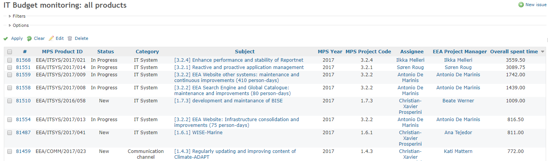
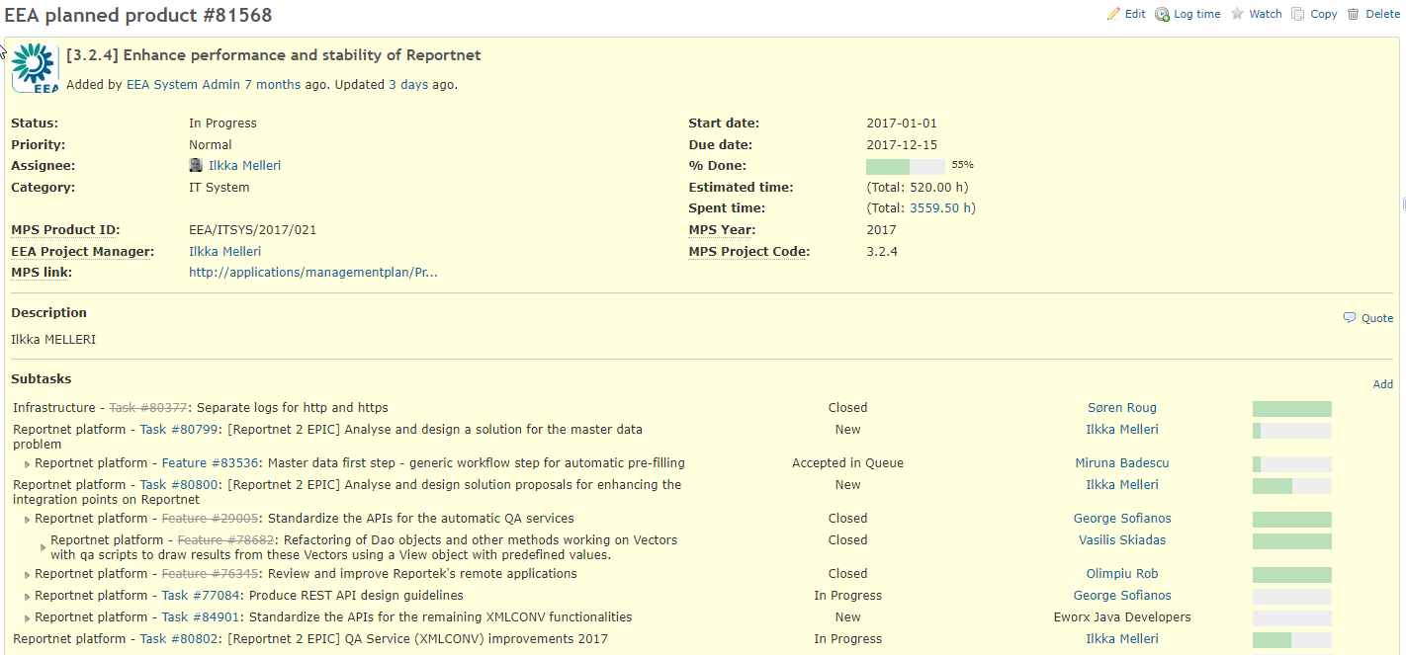
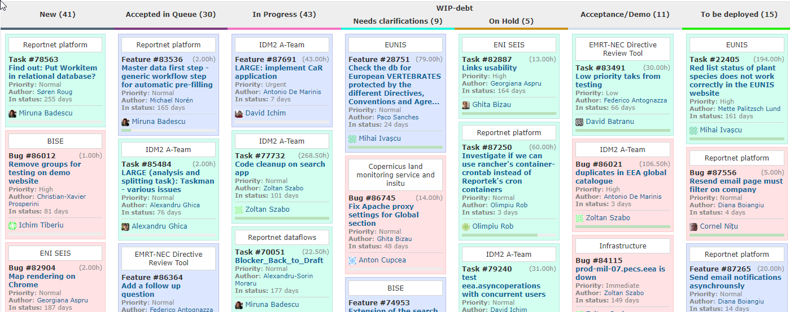

Way forward
Based on our analysis and comparison, we recommend to:
- Keep using Redmine as the issue management tool, using the on-premises hosting scenario.
- Extend its area of application to the SCM recommendations (implemented as a new project). Each recommendation will become an issue and can be linked to issues from other projects, following the EEA model; Upload recent recommendations (e.g. from 2016 onwards, to be agreed);
- Replace the current installation (support.informea.org, version 2.4.5) to the latest stable version (3.4.2);
- Migrate all relevant open issues from support.informea.org and Trello to the new instance;
- Create the SCM project and showcase how recommendations can be linked to software requests (InforMEA portal, e-learning etc.);
- Create new accounts (e.g. from each MEA secretariat)
- Communicate to all stakeholders the new procedures for reporting incidents related to InforMEA portal and for monitoring the SCM recommendation status; Optionally: organize a short webinar or video training for the stakeholders.

Annex 1 – EDW report on InforMEA Sever health status
Annex 2 – EDW report on GraphQL
Annex 3 - EDW report on JiRA
CBD Treaty Text - http://cbd.un.mangiafico.com/cbd.xml; Decision X/2, The Strategic Plan for Biodiversity 2011-2020 and the Aichi Biodiversity Targets - http://cbd.un.mangiafico.com/cop10dec2.xml
SCM 8/18 - the MEA KM team guided by the working group supports MEA Secretariats with tagging in the context of strategic planning questions, internal processes, the identification of appropriate libraries and ontologies, and in the context of piloting, agreed upon solutions, such as the Climate Tagger API presented at the meeting; SCM 8/20 - At least two MEA Secretariats engage in a pilot using the Climate Tagger platform (integrating the LEO ontology and other taxonomies as appropriate) and possibly also the Pool Party thesaurus management tool, to investigate the benefits and impact of auto-tagging and linking data initiatives for InforMEA users.
SCM 8/25 (Promotional Activities) - In the context of UNEA and the pollution and health theme it is recommended that efforts are made to build a specific promotional activity around the MEAs and InforMEA, including a short training course with promotional certificates.
SCM 8/27 - … ensure InforMEA is present on all websites and all MEAs and InforMEA partners should also actively look for other ways to incorporate InforMEA outreach in their own individual outreach efforts. Communication Officers at each MEA and at other key IKM stakeholders should be enabled and mobilized in these efforts
Edited to remove the names of individuals.

