InforMEA
Report of the 10th Steering Committee Meeting
Montreux, Switzerland | 11-14 June 2019

EXECUTIVE SUMMARY
I. Background 1
II. Meeting Summary 2
III. Outcomes 4
IV. Annexes 4

The 10th Meeting of the InforMEA Steering Committee provided an opportunity to reflect on a decade of progress, and to consider the strategic direction of the Programme moving into Phase III as well as what the committee hopes to accomplish in the coming couple of years.

The meeting discussed the role InforMEA has played as a community of practice for MEAs, and as a resource for MEA secretariats, focal points, researchers, students, civil society, and others. Looking forward, participants discussed demonstrating the collective contribution of MEAs towards internationally agreed goals like the SDGs or post-2020 biodiversity framework; engaging with other areas of public international law; harnessing semantic indexing tools towards collective intelligence; agreeing upon technical standards for document schemas and formats; and enhancing and leveraging InforMEA’s E-Learning tool for education and outreach.

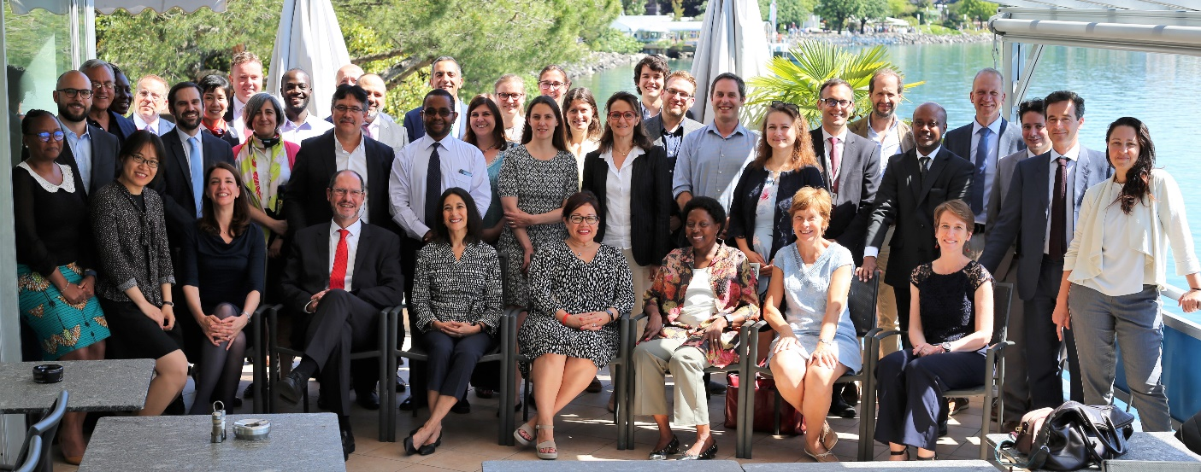

Background

UN Environment has supported the InforMEA Program since 2010. InforMEA currently brings together 60 global and regional legally binding treaties from 22 secretariats, hosted by five UN organizations and the International Union for Conservation of Nature (IUCN). InforMEA is also open to partners and observers.
The InforMEA Program is committed to knowledge sharing and harnessing technological advances to support MEAs and their Parties. It has been supported by the European Union since 2014, and benefits from an ever-growing membership. The purpose of the meeting was to obtain the MEA members’ guidance in the context of the project’s further development and priorities, particularly as the project moves to its third Phase.

Meeting Summary

- The 10th InforMEA Steering Committee Meeting was opened by Ms. Elizabeth Mrema, Director of the Law Division of UNEP. During her remarks a minute of silence was observed in honor of the late Mr. Bradnee Chambers. Participants then began a tour-de-table, after which the InforMEA team presented an annual progress report.
- Subsequently, participants separated into the first of three working group sessions, focused on (1) E-Learning, (2) Outreach, and (3) Technical issues, with E-Learning and Outreach forming a combined group. E-Learning and Outreach group members discussed how to harness the reach of the E-Learning tool in institutions around the world, using E-Learning as a motor for outreach, targeting a youth usership, and raising awareness about the collective work of MEAs. The Technical group discussed hosting of the ever-growing platform of InforMEA, document schemas, and the roll-out of a new semantic indexing software.
- The following day, the second working group session focused on (1) Internationally-Agreed Goals, and (2) Partnerships. The Goals group confirmed the SDGs mapping that had taken place in the previous years, and discussed how to visualize treaty related information, how to show MEAs’ collective contributions to the SDGs and other goals, and how make the connections deeper. Two presentations were given to the full group on potential partnerships: the first by the WTO, on efforts to capture trade obligations in MEAs and environment-related notifications to the WTO; and the second by the UNEP Science Division on the World Environment Situation Room (WESR) on the bridge between statistics and geospatial data and the information collected and promulgated by the MEAs.
- The third working group session looked at (1) Document Standards, Legislative Projects, and related Partnerships, and (2) Harnessing Artificial Intelligence. The session began with three presentations: the first by UNODC-SHERLOCK on their open-access database on organized crime, including wildlife crime; the second by the UN High-Level Committee on Management (HLCM) on the adoption of Akoma Ntoso as a common document standard for the UN; and the third by the company Libryo, on their efforts to collect legislation and make it organized and available, including through translation into Akoma Ntoso. The Harnessing Artificial Intelligence Group looked in particular at tagging and the uses and potentials of Poolparty, a new semantic indexing software InforMEA has acquired since the previous Steering Committee Meeting.
- On the afternoon of the third day, the group was joined by a number of MEA executive heads and observers to celebrate 10 years of InforMEA. The session began with welcome remarks from Ms. Mrema, and from Ms. Ivonne Higuero, Secretary General of CITES and co-chair of the InforMEA process. Ms. Cristiana Pașca Palmer, Executive Secretary of CBD provided her address by video, and a statement was delivered on behalf of Ms. Alicia Bárcena, Executive Secretary of ECLAC.
- Following a presentation on the history of InforMEA by the InforMEA team, a panel discussion by executive heads considered the main achievements and key aspirations of InforMEA. The panel included Co-Chair Ms. Ivonne Higuero, Ms. Tina Birmpili, Executive Secretary of the Ozone Secretariat, Ms. Martha Rojas-Urrego, Secretary-General of Ramsar, Mr. Carlos Martin-Novella, Deputy Executive Secretary of BRS, and Ms. Claudia Ten have, Senior Policy Coordination Officer of the Minamata Convention. Panelists discussed the benefits InforMEA has brought over the past 10 years, the key users of the platform, and the untapped potentials and other opportunities for InforMEA to pursue in the coming years.
- The WTO was warmly welcomed as an observer and delivered brief remarks on collaboration with MEAs and InforMEA.
- On the final day, progress on the Data-Reporting Tool (DART) was presented to the group. Following the presentation representatives of the European Union and the Federal Government of Switzerland, who both support DART, shared their perspectives on knowledge management in the current environmental governance context. During the closing session, participants gave final reflections on InforMEA at this transitional moment, as well as final comments for discussion.

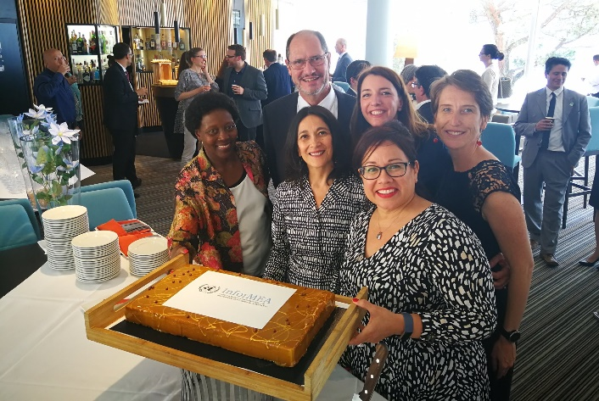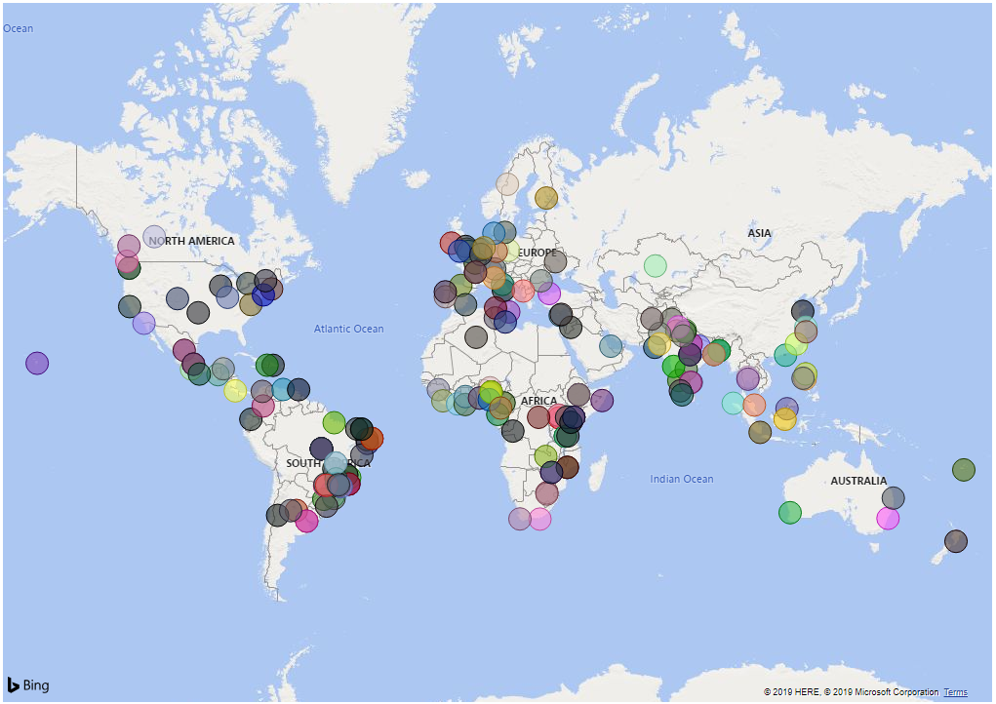
Celebrating 10 years of InforMEA InforMEA E-Learners’ institutions, around the globe

Outcomes

Each of the components discussed led to a set of recommendations which were presented, in draft form, on the morning of the third day, and subsequently reviewed by participants. They are included in Annex I of this document.

Annexes

Annex I - Draft Recommendations (you may need to copy-paste into a browser)
Annex II - Agenda and Participants List
Annex III - Background Documents
Annex IV - Presentations and Photos

Outreach - Webstory

Observers include the IMF, IPBES, UNDP, UNITAR, the European Environment Agency, UNEP-WCMC, the Environmental Management Group, the International Institute for Sustainable Development (IISD), and the WTO.
https://docs.google.com/document/d/1AdnB6SYokyXd7AQFSVY2dTZHkQWooib46mz3wIho8B8/edit
https://drive.google.com/drive/folders/1XaZBBBpLR8PmbK4Pl1Ka59tLE4iOYYfe
https://docs.google.com/document/d/1GCf-w_Z_WQn5GPgzAgaBM7Ksh0ikkLP9OxpFv0v4TD0/edit#heading=h.gjdgxs
https://drive.google.com/drive/folders/1sL0OUU4SQjuett5PVnGHa86aqqk6gRm-
https://drive.google.com/drive/folders/15qyQUp22rV5rJweqqP_PYB_uuhwRWcJT
https://drive.google.com/drive/folders/1pRGF0SBqK1gOs0lS-CDxLEskUkYq02T2
https://www.unenvironment.org/news-and-stories/blogpost/celebrating-10-years-collaboration-informea-collective-intelligence

